# NAME: SUSAN PAUDEL

# ID: C7227235

# GROUP: A

# TUTOR: PRATIK SHRESTHA

# OVERVIEW OF MY PROJECT

Before starting, our project has been divided into three components. In your component first we have store the data of books, cds and games using form and fetch and delete the data from json file using php OOP concept. We have provided the screenshots of required tools for laravel installation like: composer, php, IDE, xdebug and evidence of project screenshot.

Component second was based upon the converting the php files into laravel project like in component first was in json file but now we have to create model, migration, views, controllers for interacting with database to store data. As model is used for manipulating the database, view used as user interface i.e. display form and controller is for building the application logics.

For component third, we have to create the website shopping sites. The name of my website is Leeds shop i.e. E-commerce website where we can shop the products like books, cds and games .E-commerce website are online portals that facilitate goods and services through means of the transfer of information and data over the internet. This is for my final project submission of advance web engineering. User can buy product faster which can save time and home delivery is also present in this website. Show of the criteria that I have followed in my project is:

* Models and migrations
* Factories (for seeding large data sets)
* Routing
* views (blade or Vue)
* Controllers
* Authentication
* Eloquent ORM
* Data searching and filtering

Moving on, After the user is authenticate user can able to add and remove the product from the cart, ,can view the order details and download it as pdf files, also have access to edit profile details from their profile dashboard and soon. If the user forgets their password they can simply click forget password form login form and verification will be send to user emails to verify account/reset password.

For guest, guest can view books, cds and games only separately. Can subscribe to the newsletter to know the latest added product, can contact us using contact form. Guest can view your social links, view our location using Google maps, able to view product description of chosen product, searched the product and sort it by title and main name while searching it will automatically sort by price i.e. filtering.

As per the admin role, admin can do crud operation of products using HTTP verbs, capable of access to view mail, can delete the customer and view admin profile.

For database section, Xampp mysqli is used as the storing container of data for this project. We have used database components like model, migration, factory, seeder where model has been used for manipulating the database, migration is for making database table, factory use faker to make dummy data and seeder has been used to store/create certain amount of data.

# Screenshot

# Frontend Part

# homepage

This is our home page navigation with sticky top. Navigation contains register from links, social links, nav logo, search form, navs links containing book, cd, game, signin from link, cart link. In the next section that is image carasoul with three different images will display with short description.

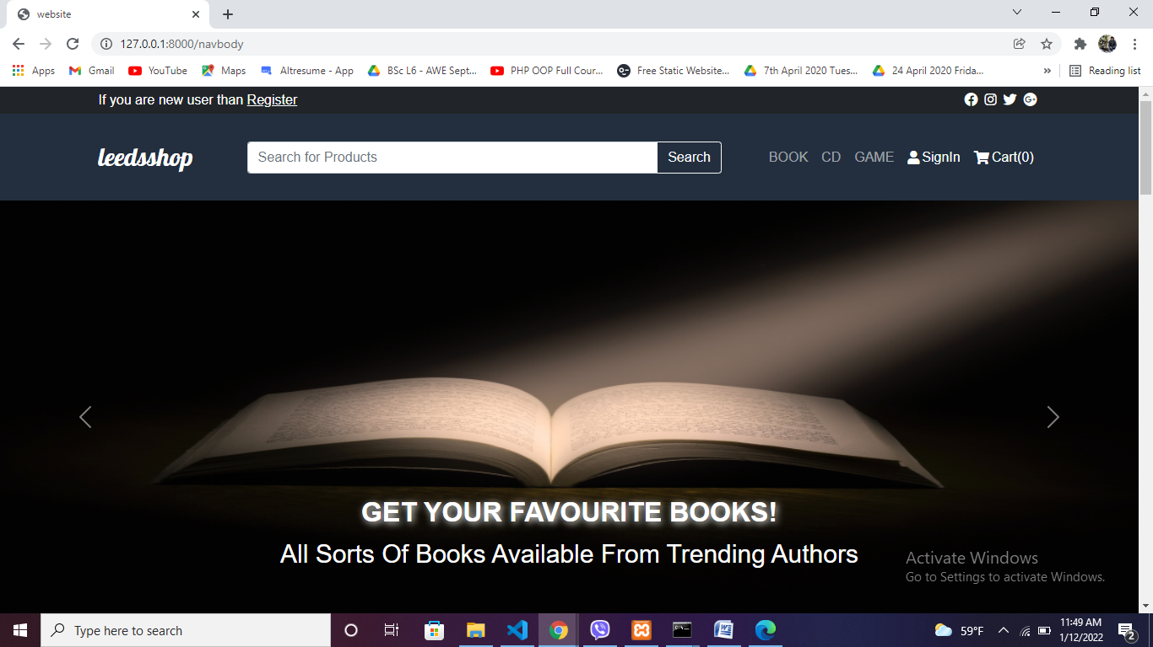

# Our products section

This is our product section where we can view book, cd, game product by clicking them.

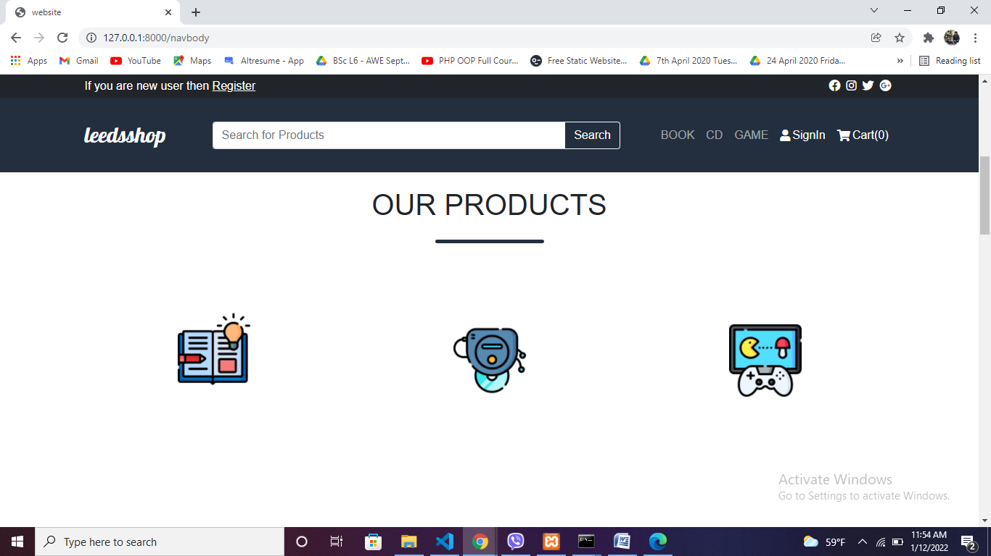

# All product section

All product section we can view all products

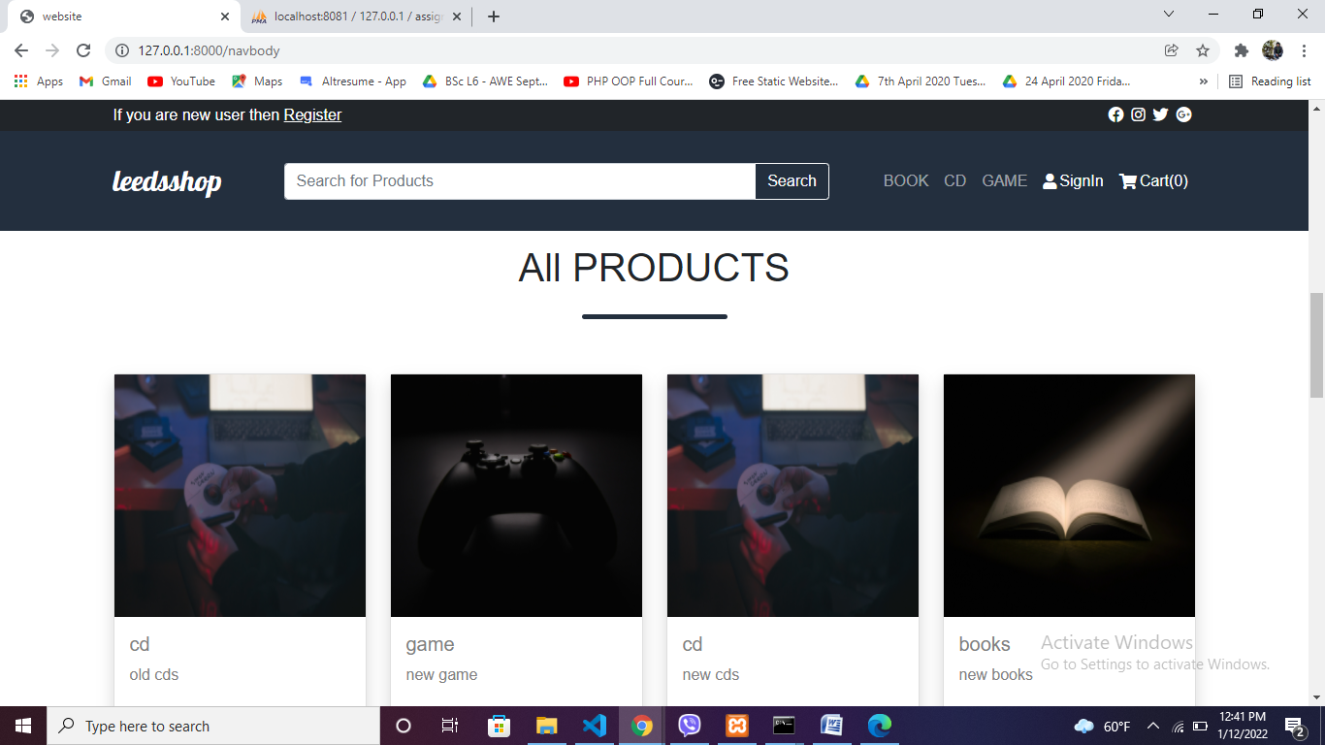

# Product details

After clicking each product details will display

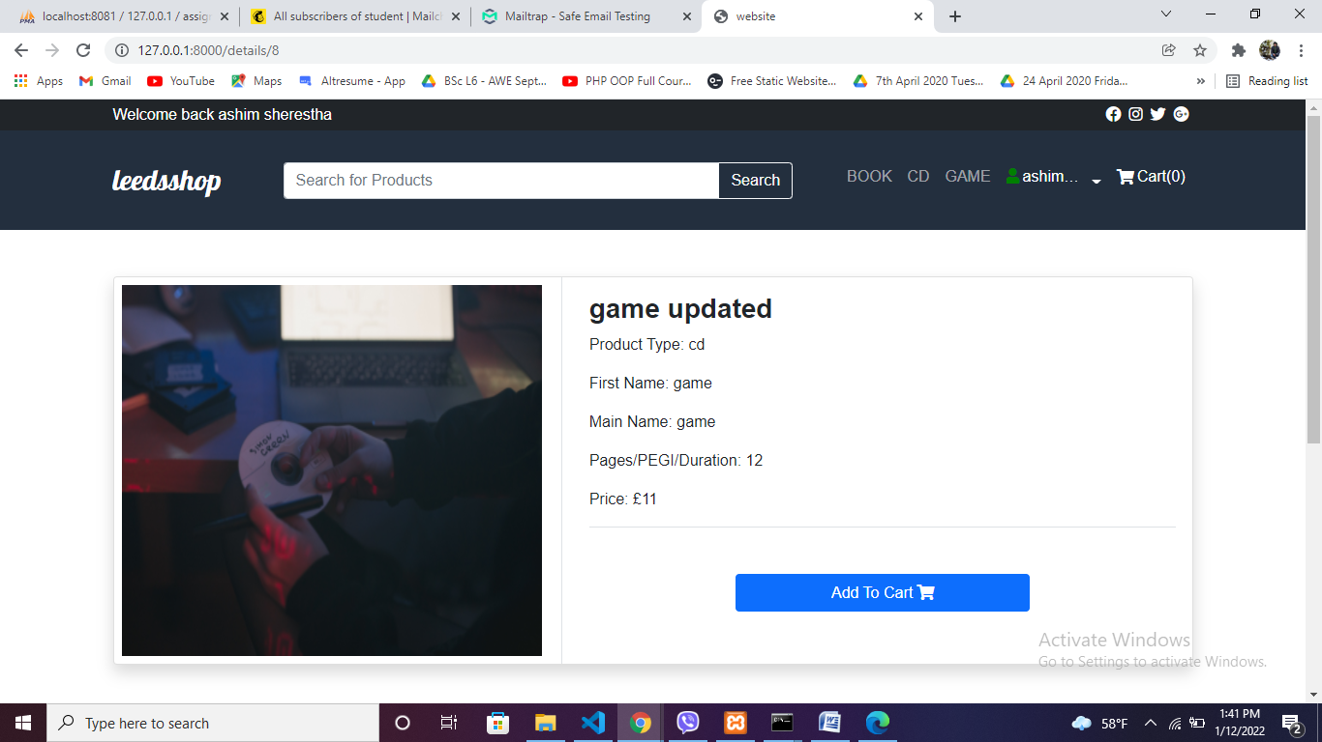

# Searched Products

Search all product related to search

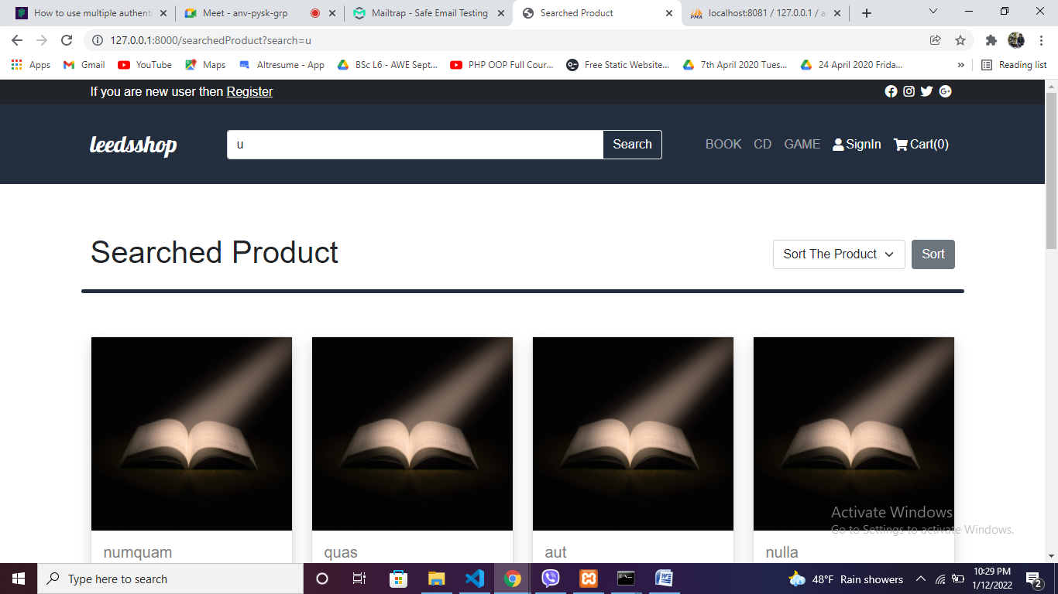

Sort product by title

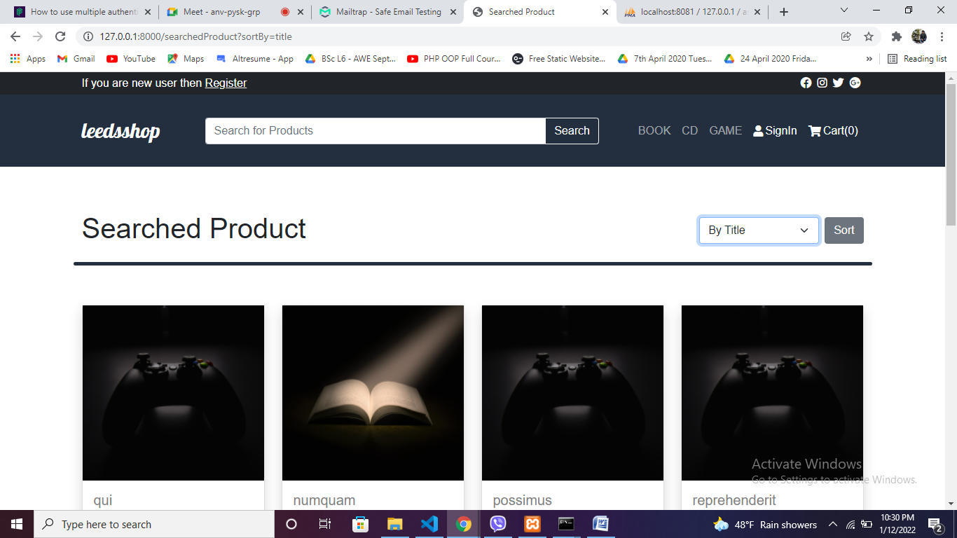

Sort product by price

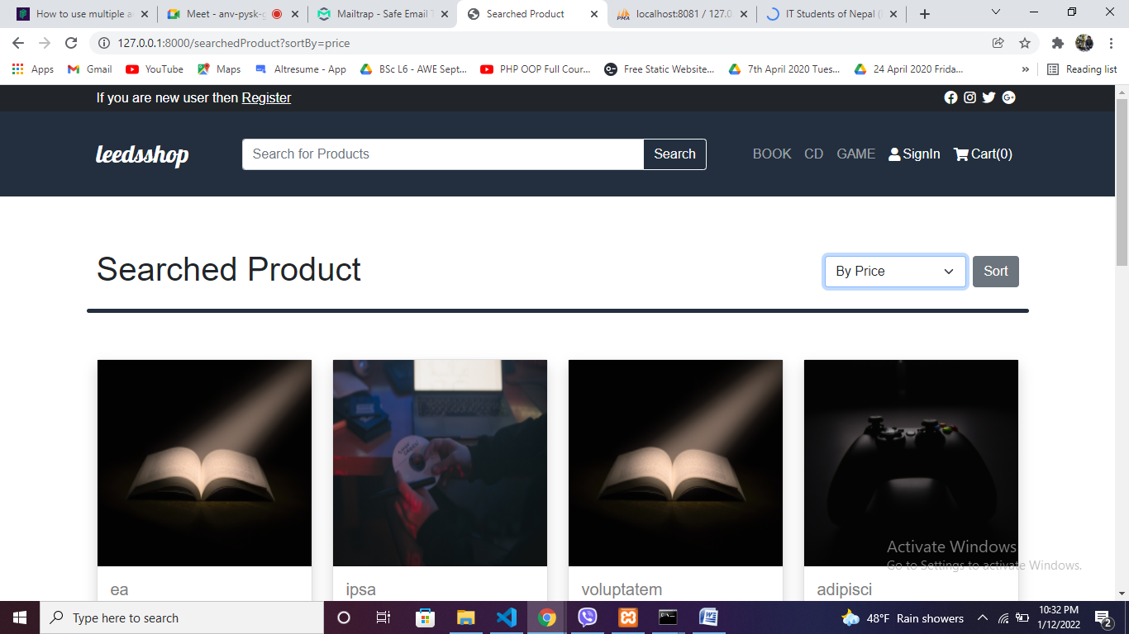

# Contact Us section

This is contact us section from home page where we can send mail to admin for support.

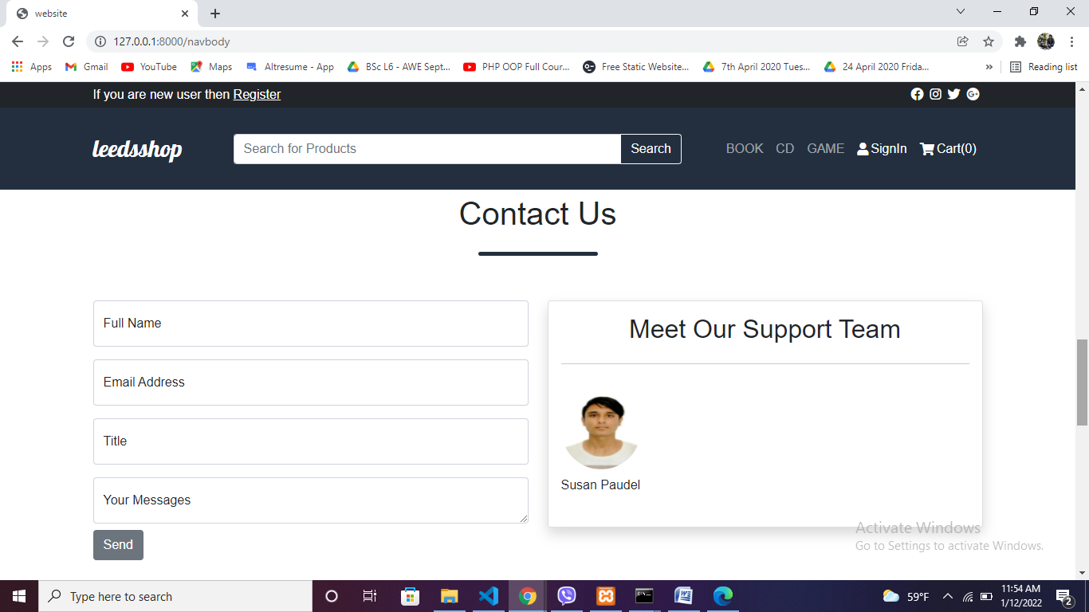

After clicking send button session message will shown

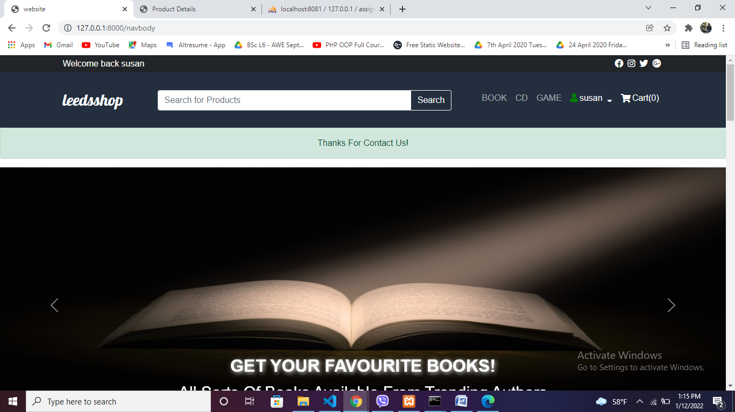

After contact admin will view your message like below:

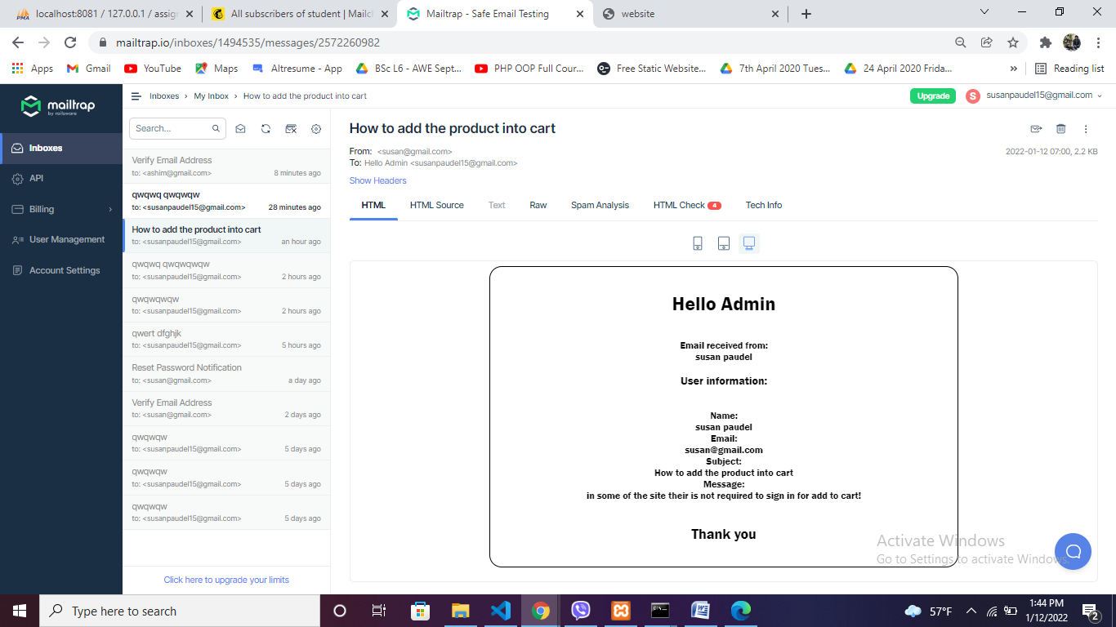

# Newsletter section

This is newsletter section where you can subscribe to our website and get notification of latest products. 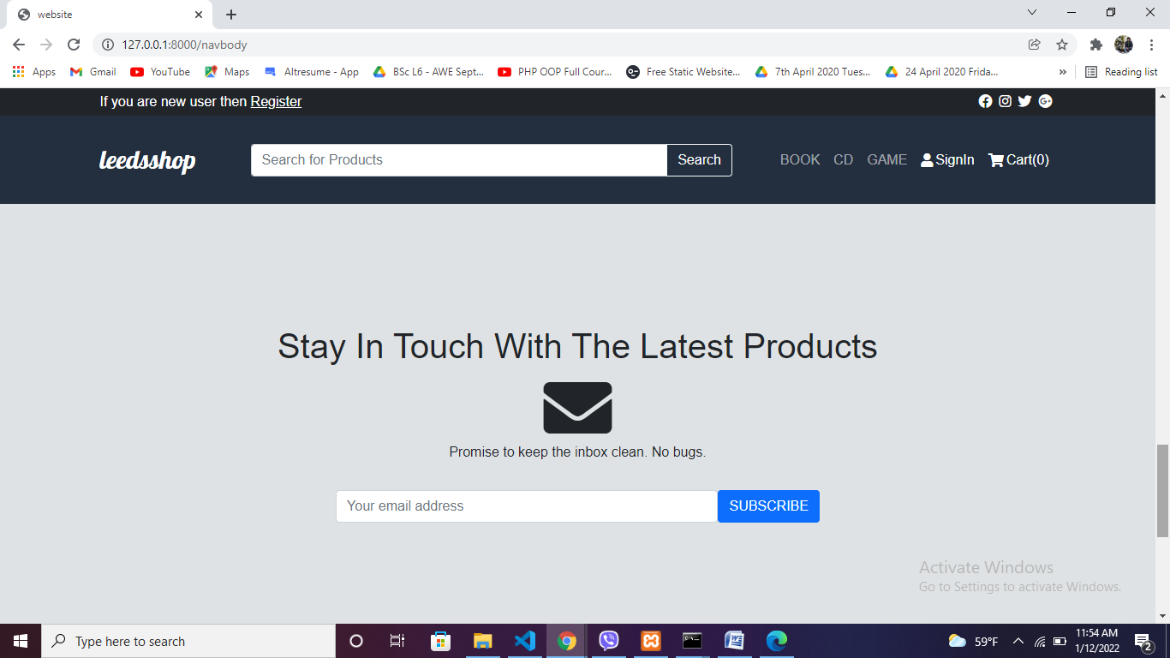

After clicking the form

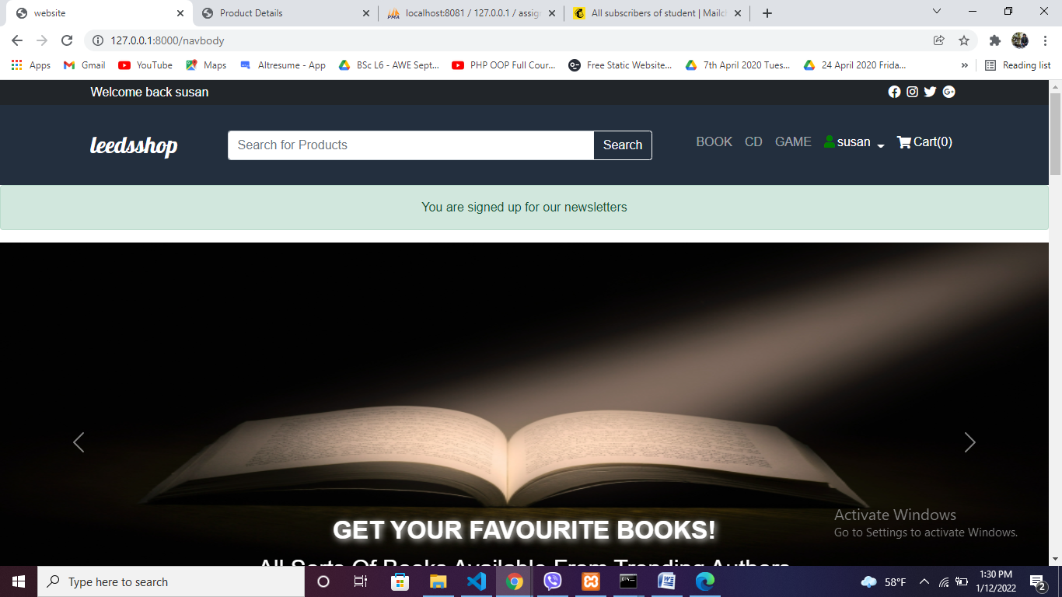

Subscriber will added to mail chimp

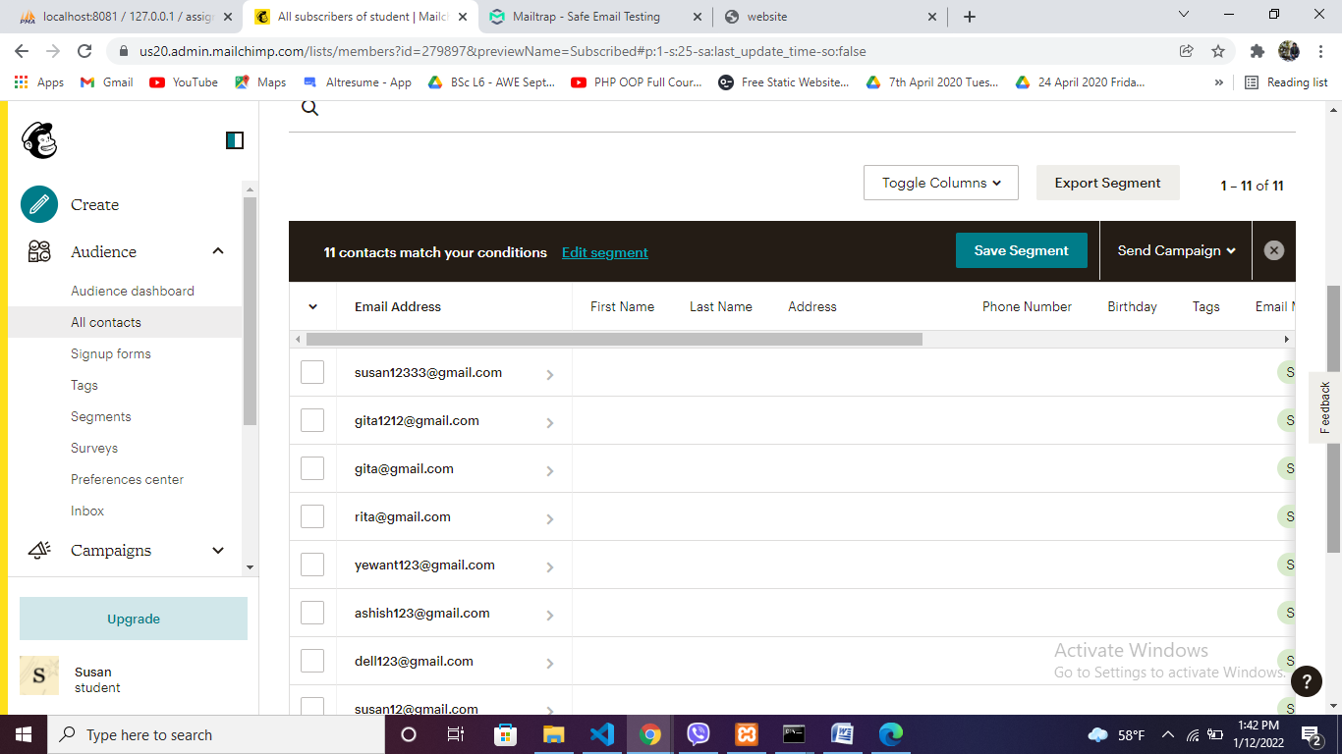

# footer

This is our navigation where I have included our services, contact us, social media and location using html iframe tag.

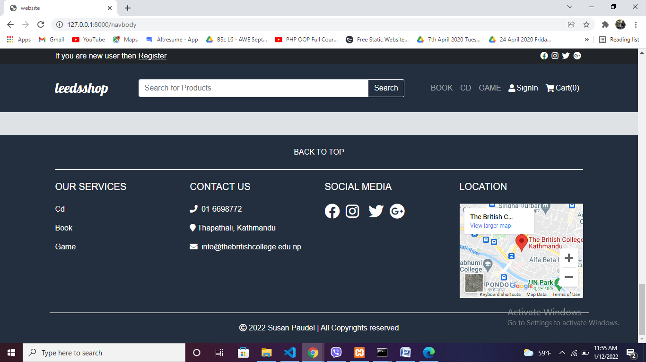

# Signin form

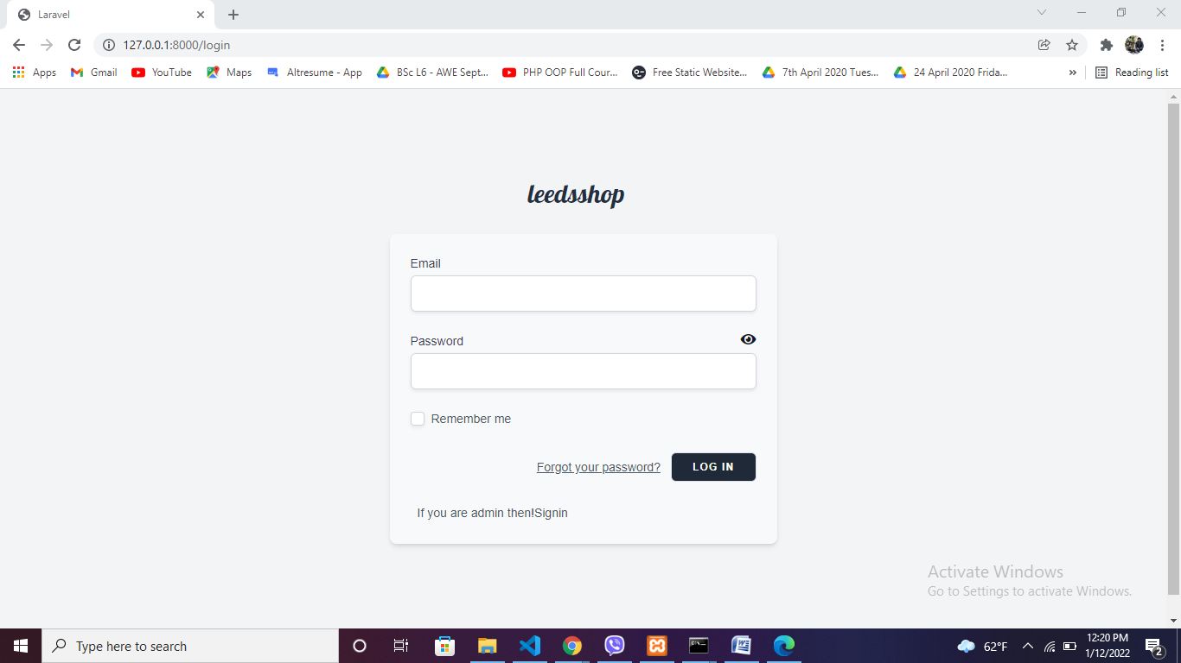

In case of forget password

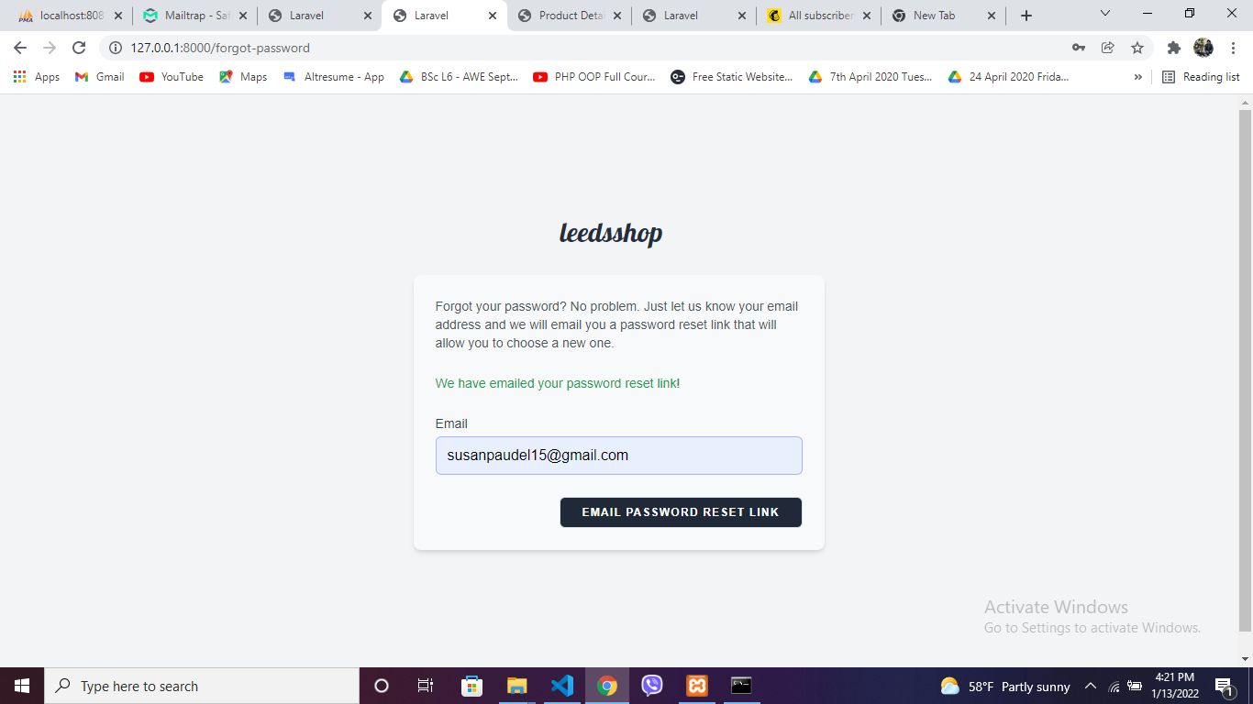

Mailchimp showing password reset notification

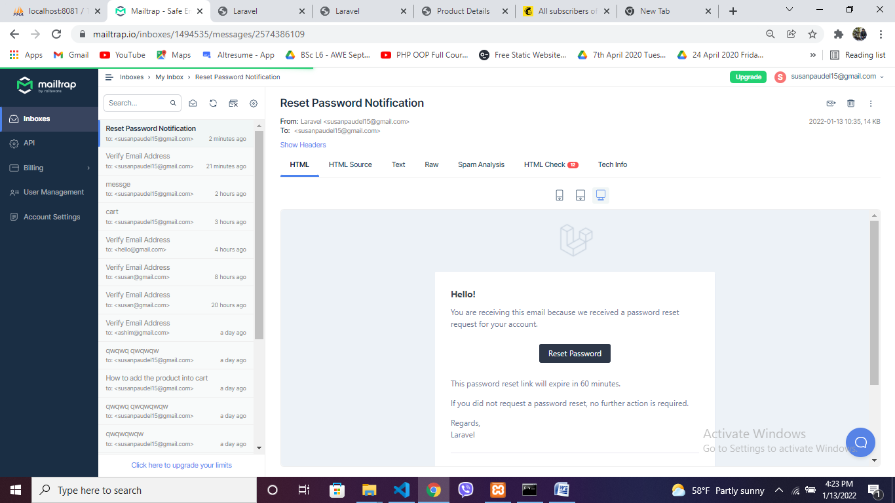

Password reset message

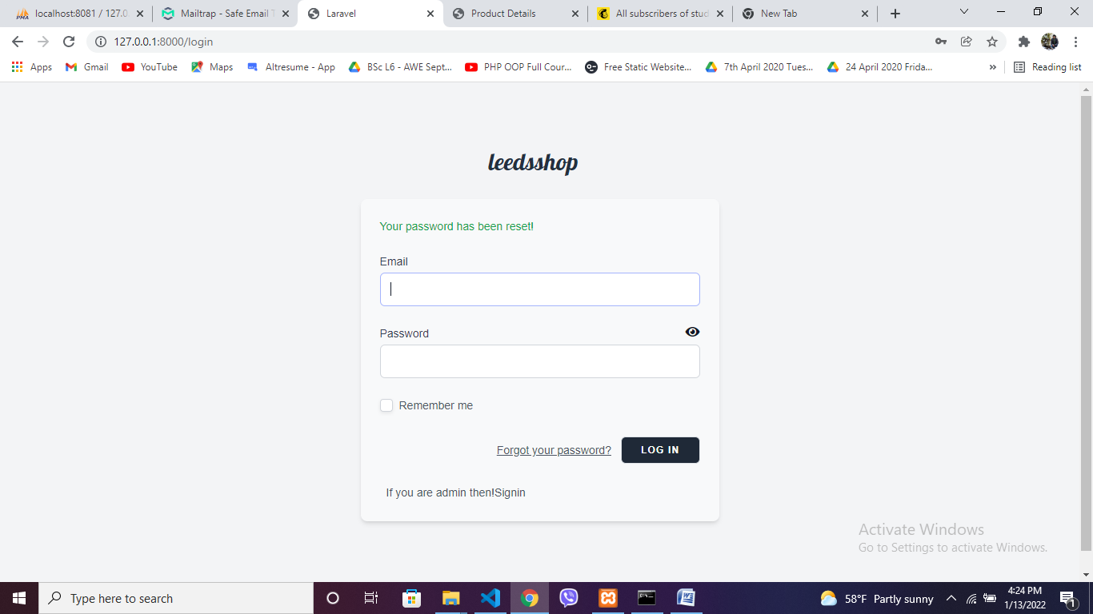

Admin login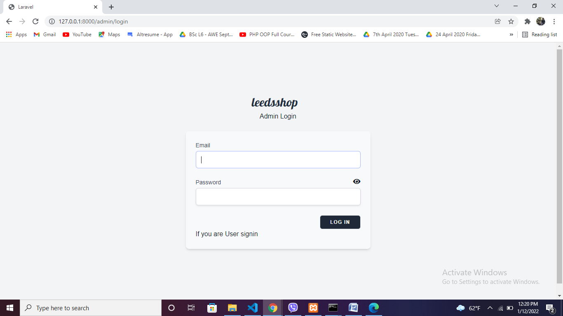

# Register form

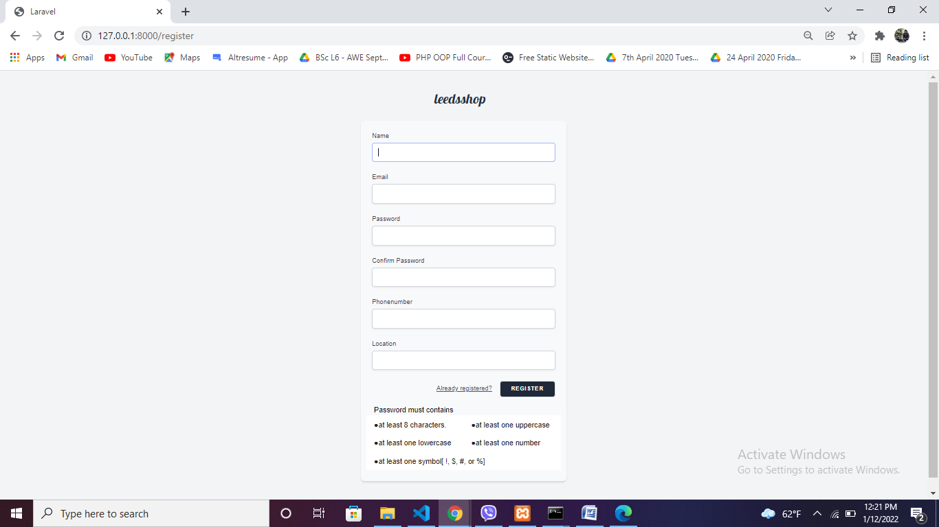

After clicking register button

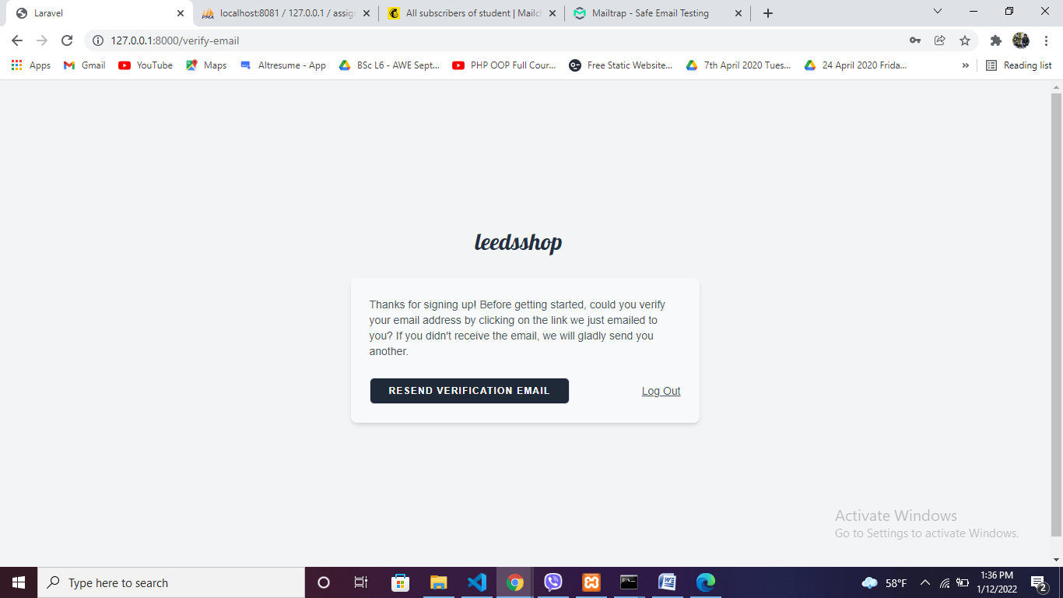

Check email varidation in mailtrap

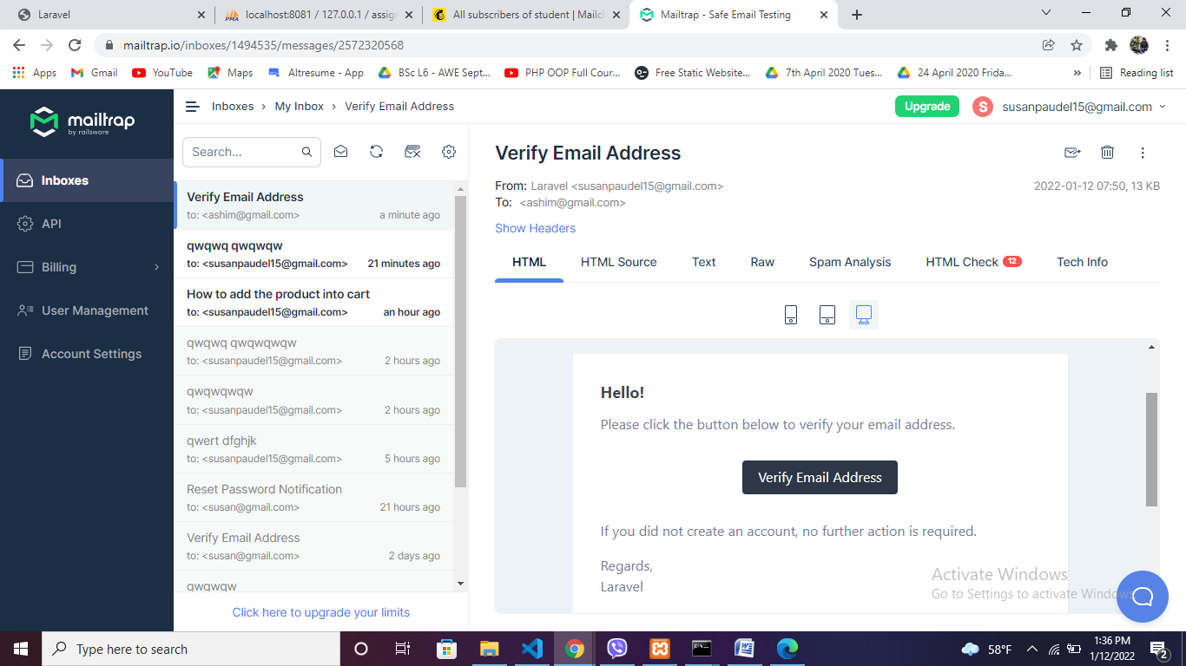

# User profile page

After verify email button is clicked User profile where user can edit their details except email address

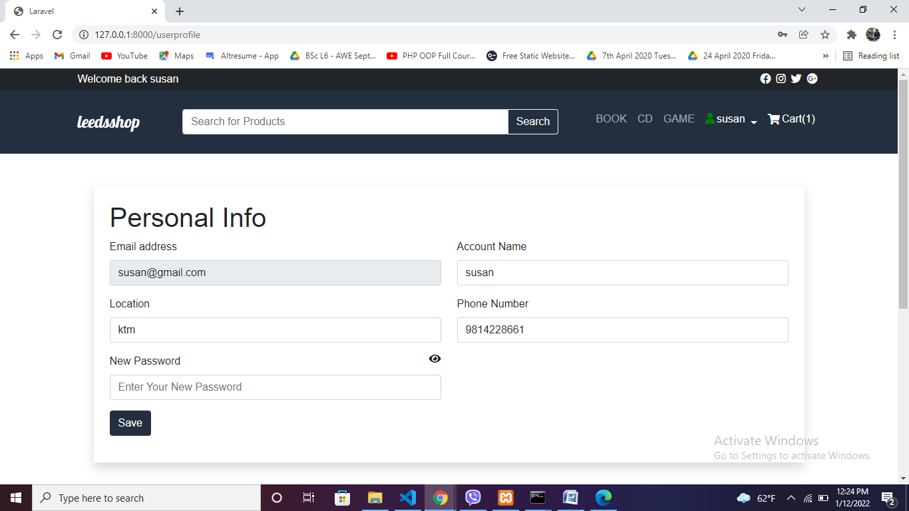

# Cart

Cart is empty after login

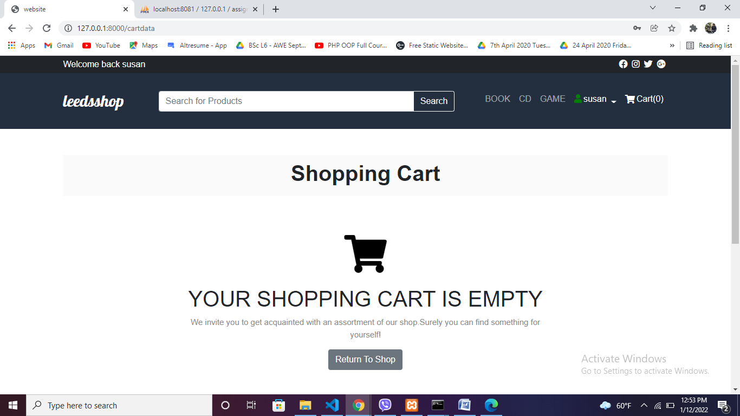

After adding product to the cart

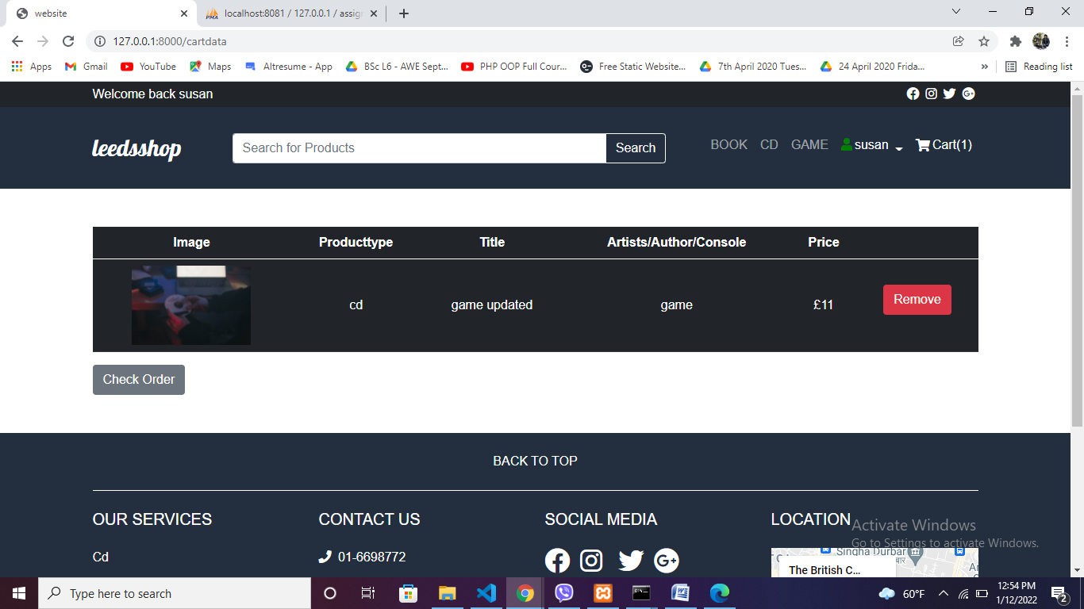

We cannot enter the duplicate product in the cart

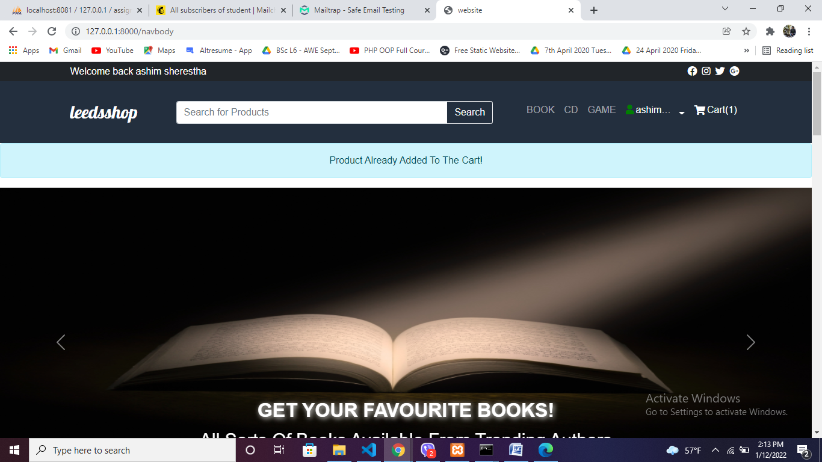

# Order details

Clicking check order it will show total amount with form to set your recent address

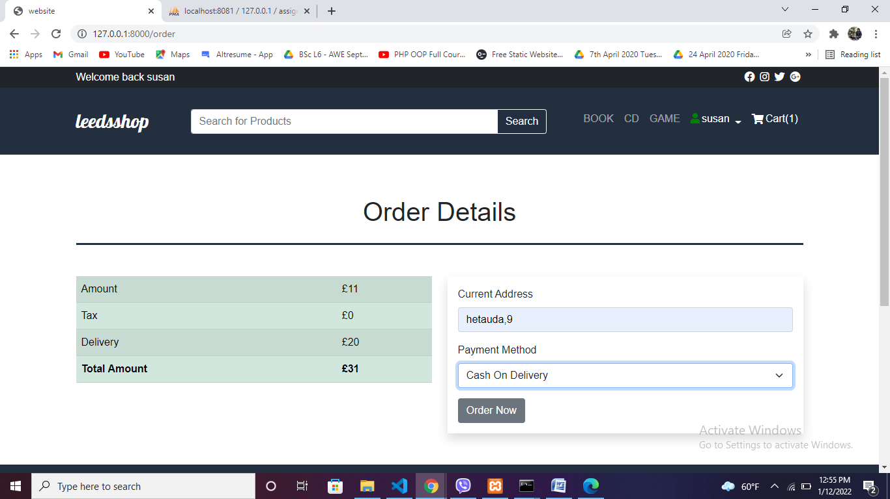Order details message

Clicking order now thanks for ordering page will display

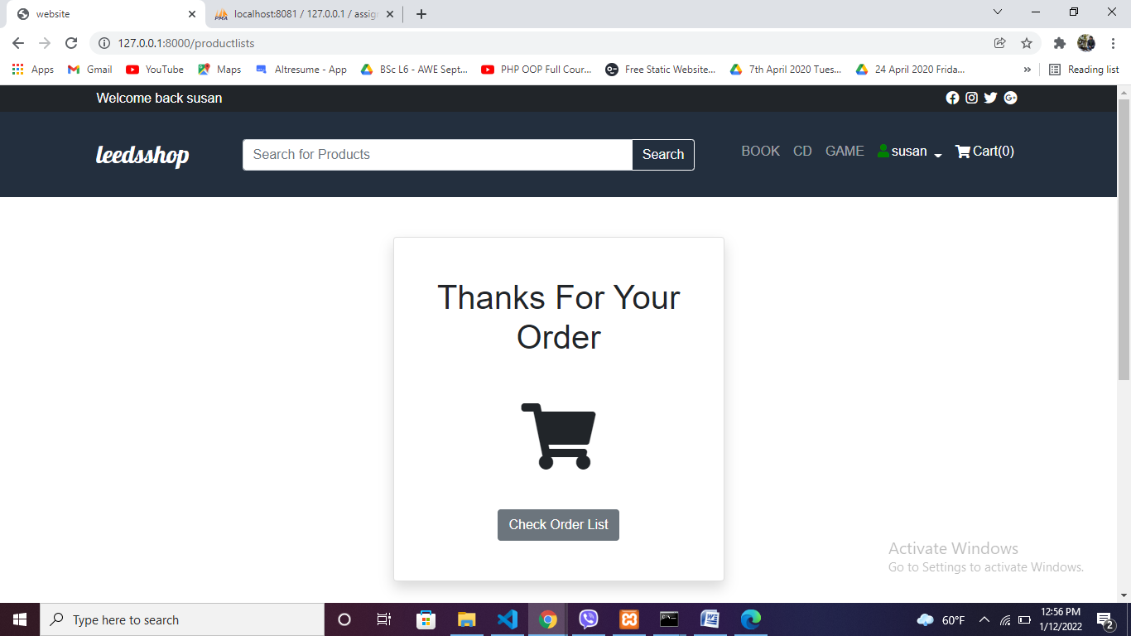

# Product details lists

After clicking check order list

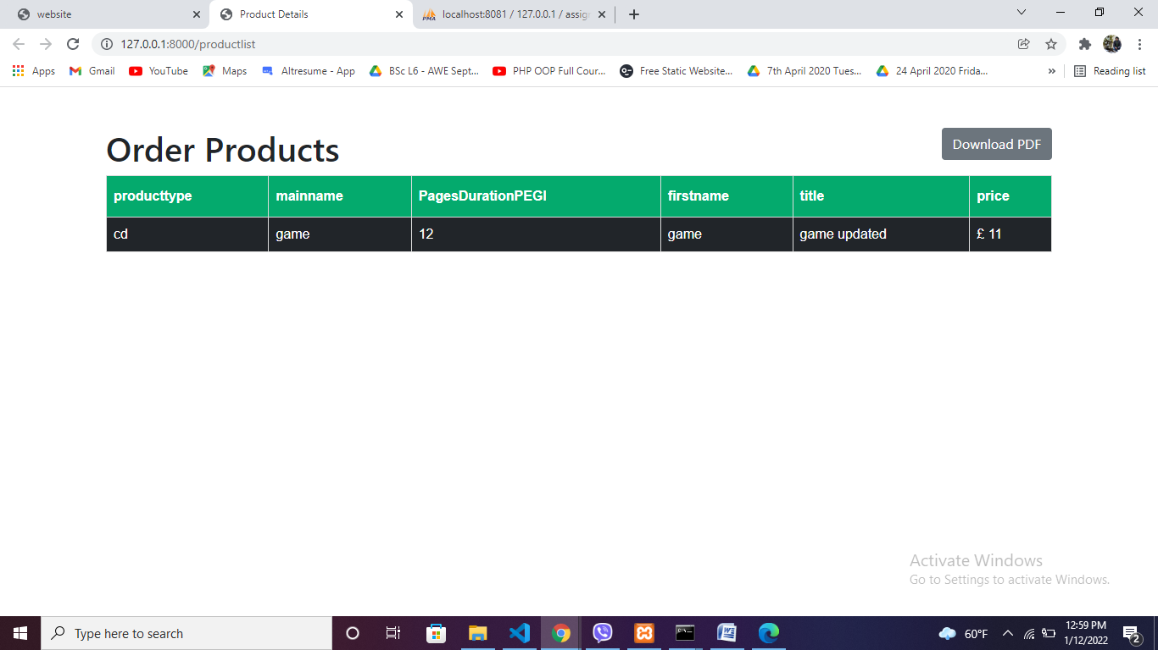PDF file

After clicking download pdf you can download the table

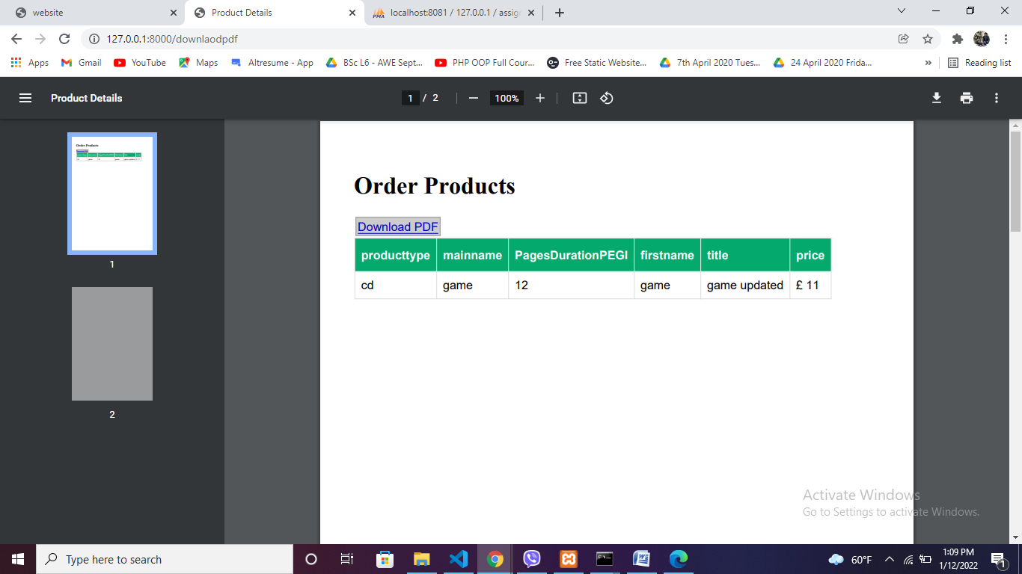

# Admin profile

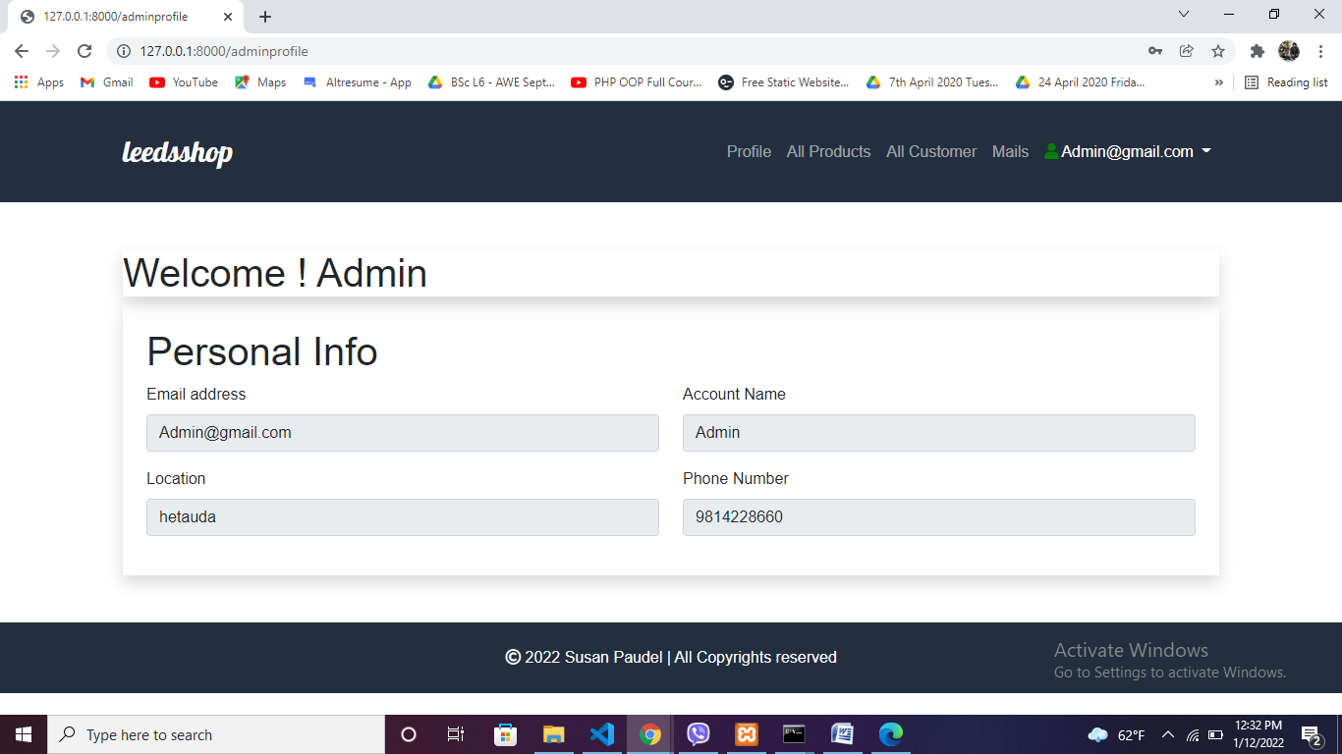

# Product crud operation

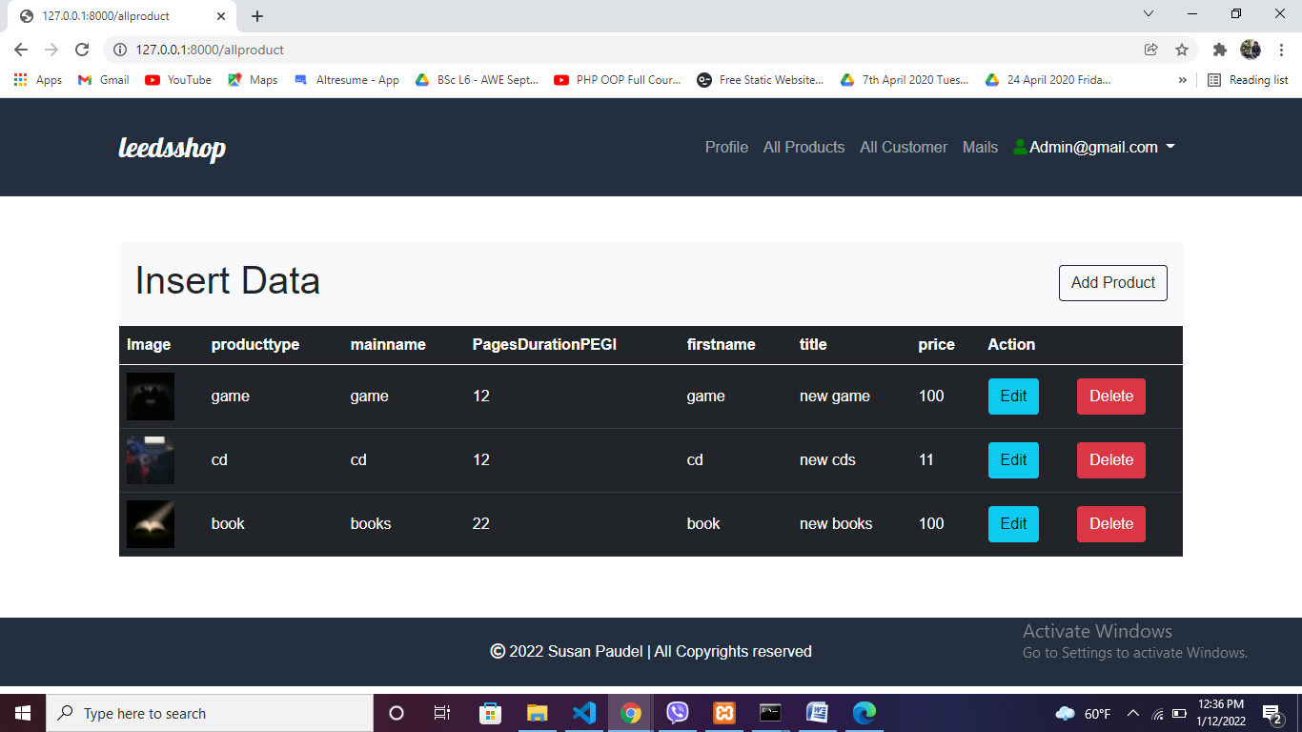

After clicking add product buttom

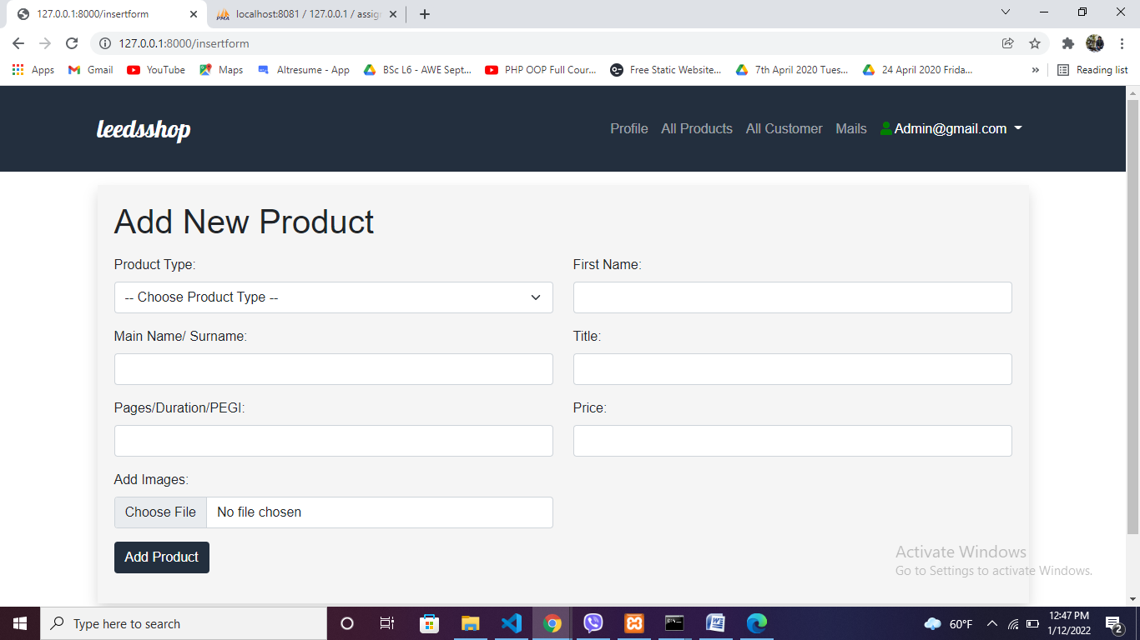

After adding product

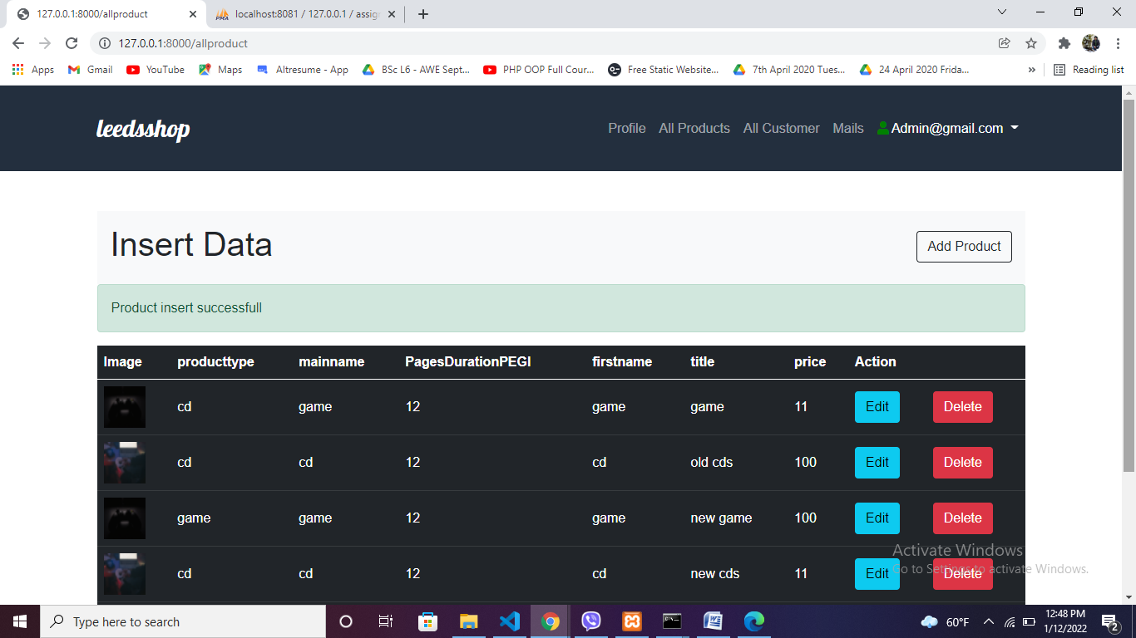

After clicking edit buttom

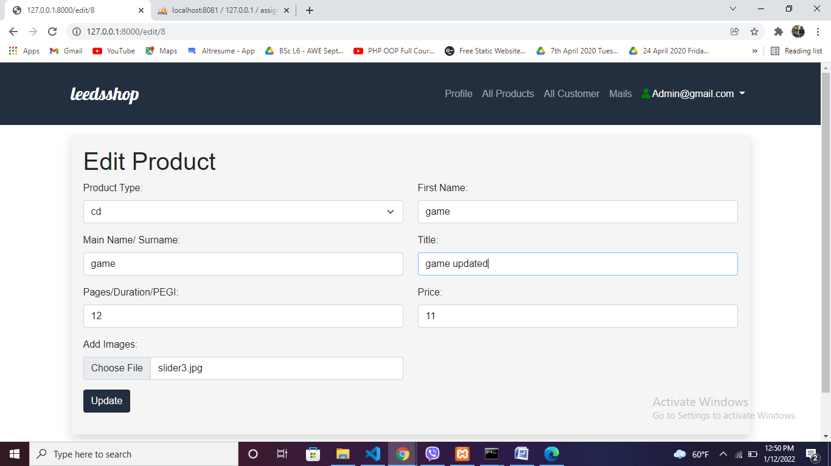

After updated button is clicked then

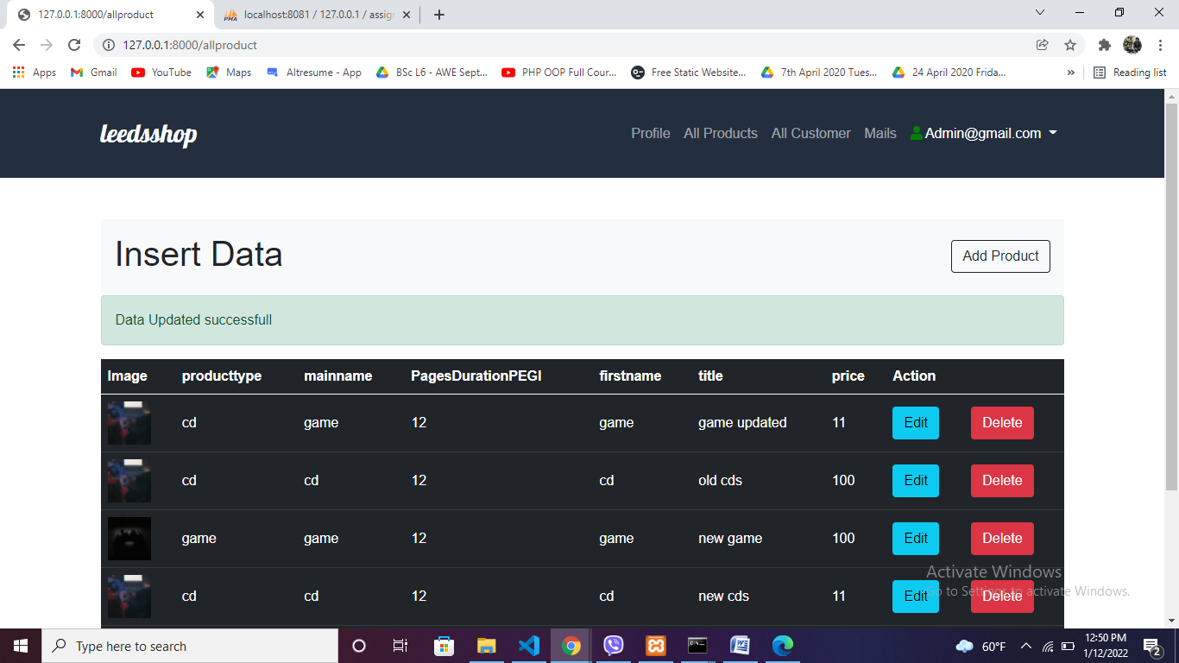

Clicking delete button

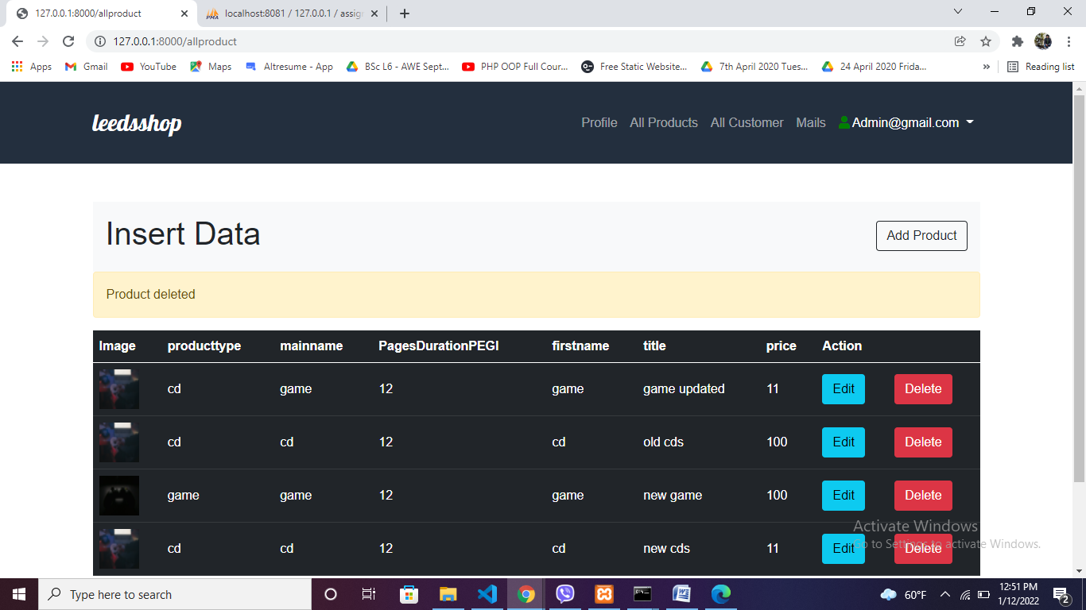

# Customer details view by admin

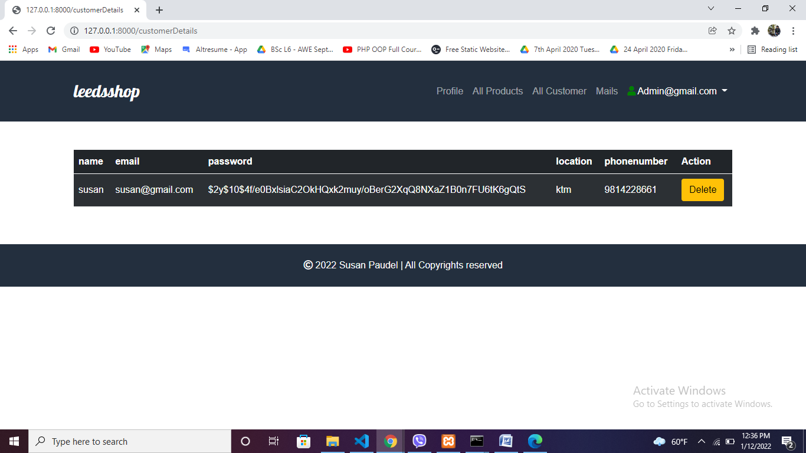

# Email sent to admin view

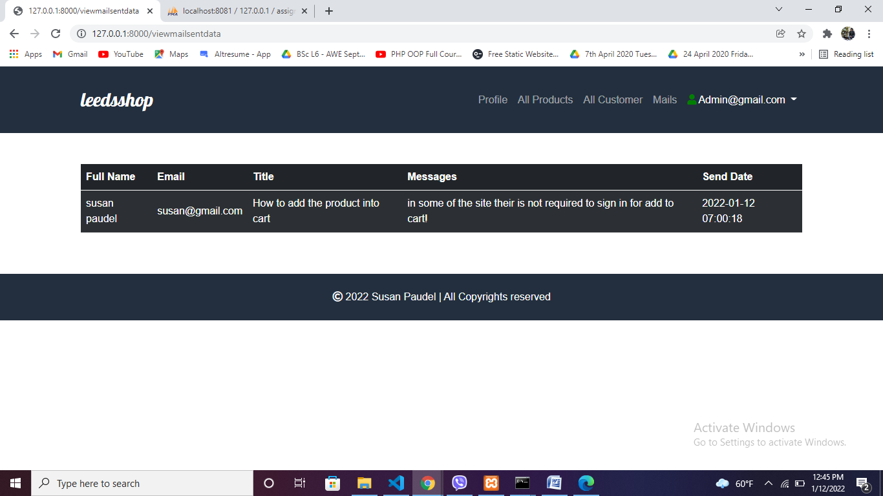

# Backend Part

# Controller

Used joins to join two table product and cart

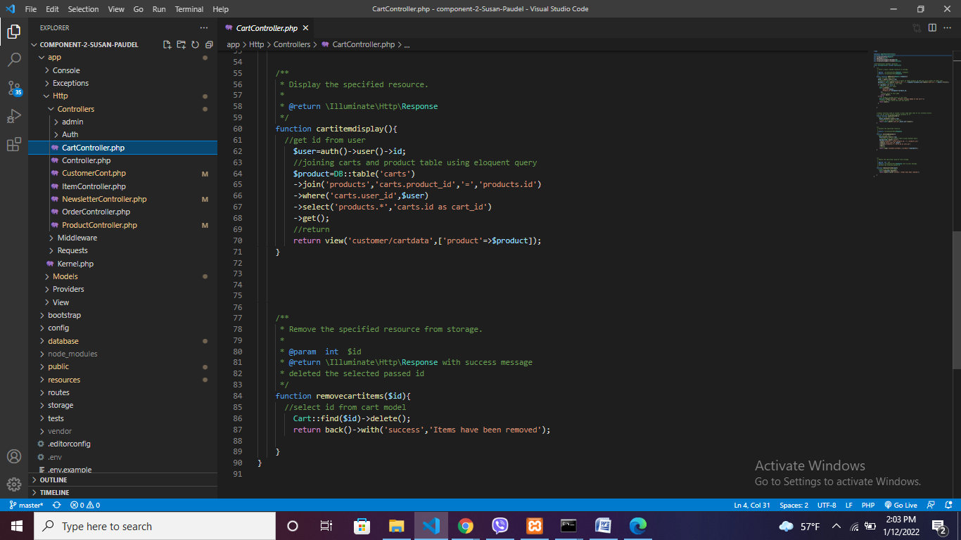

Filtering the cd,book,game

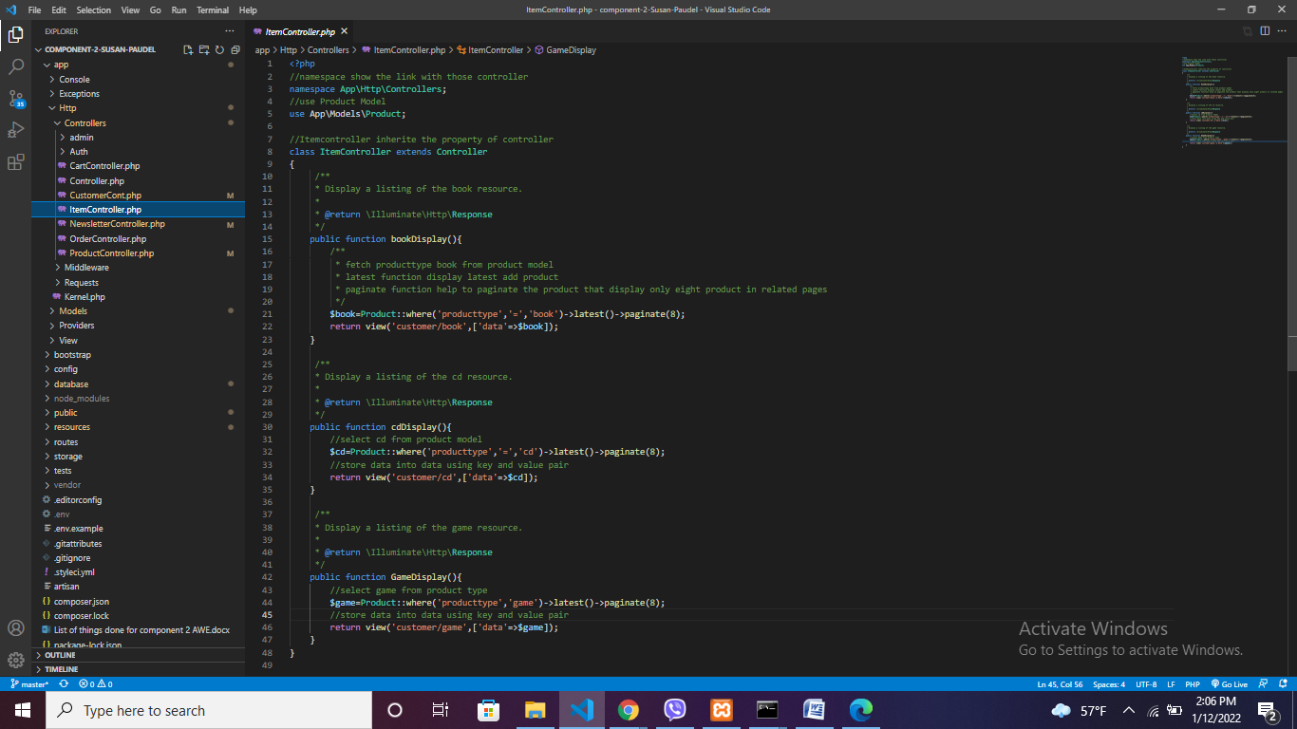

Newsletter controller api connection

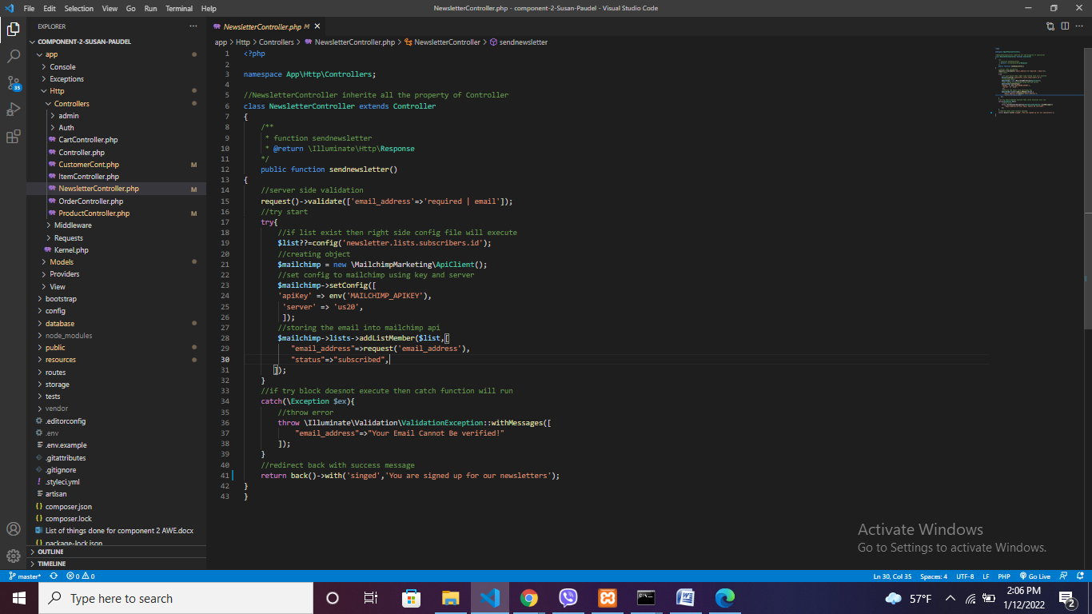

Search product and sorting it

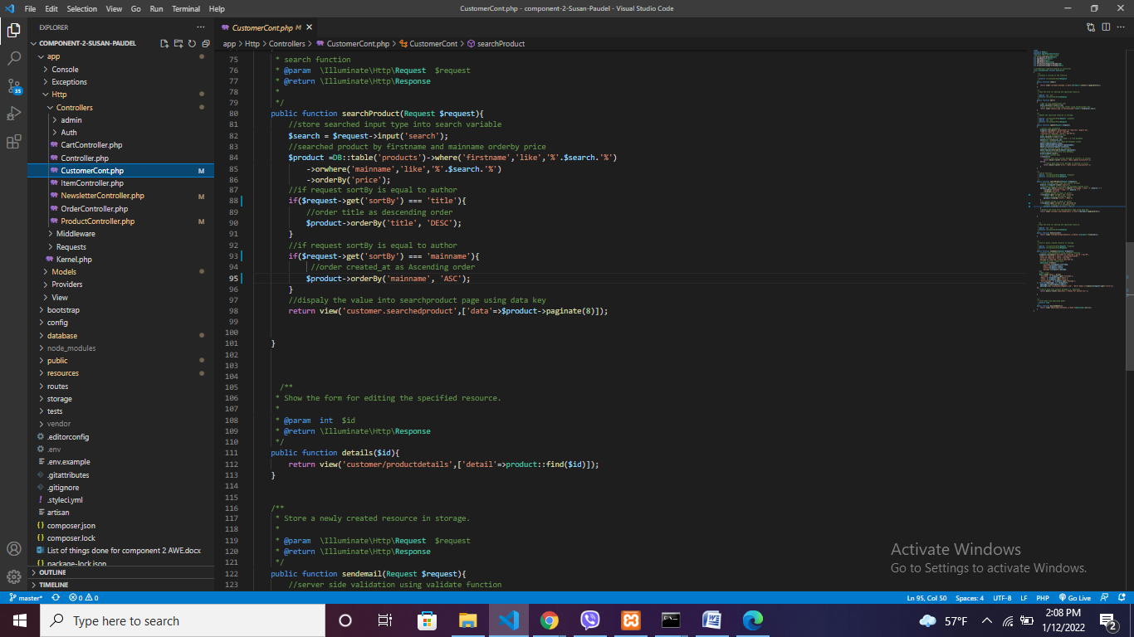

Pdf download

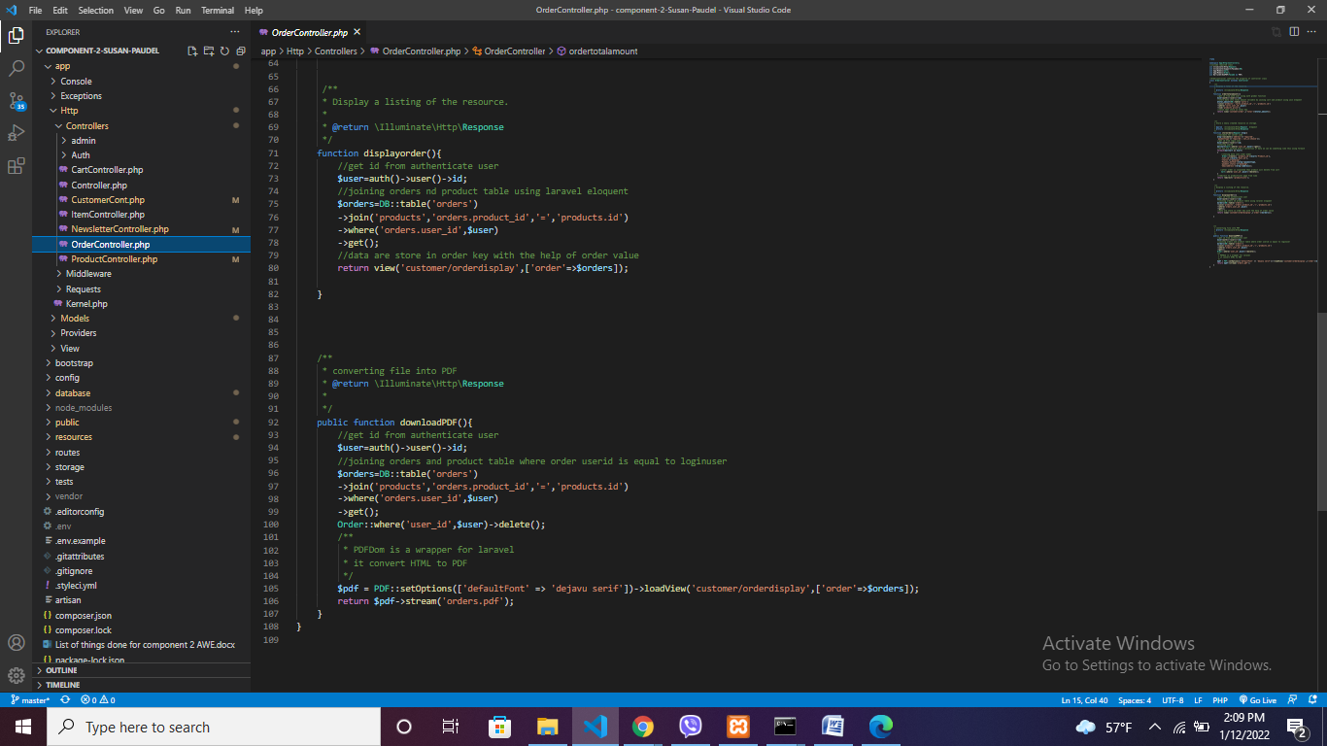

Add data to the cart, give no duplicate entry, remove from cart functions

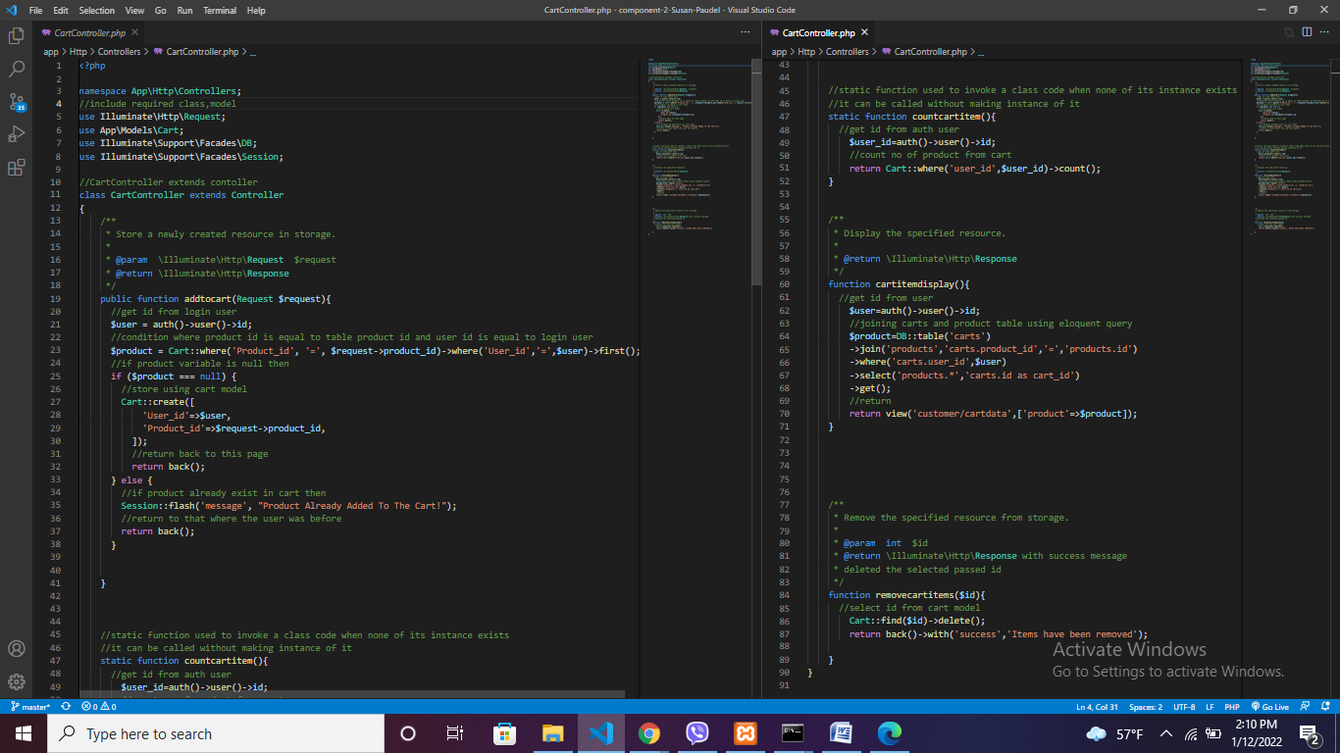

# Database table products

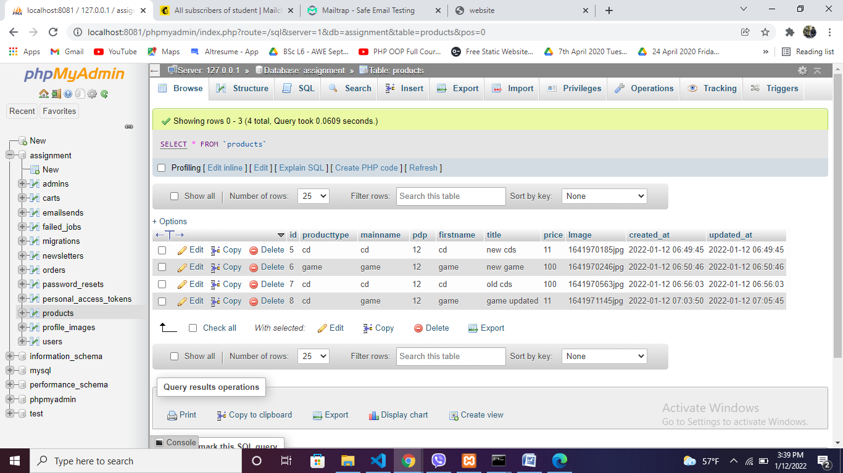

# Seeder to make admin email and password

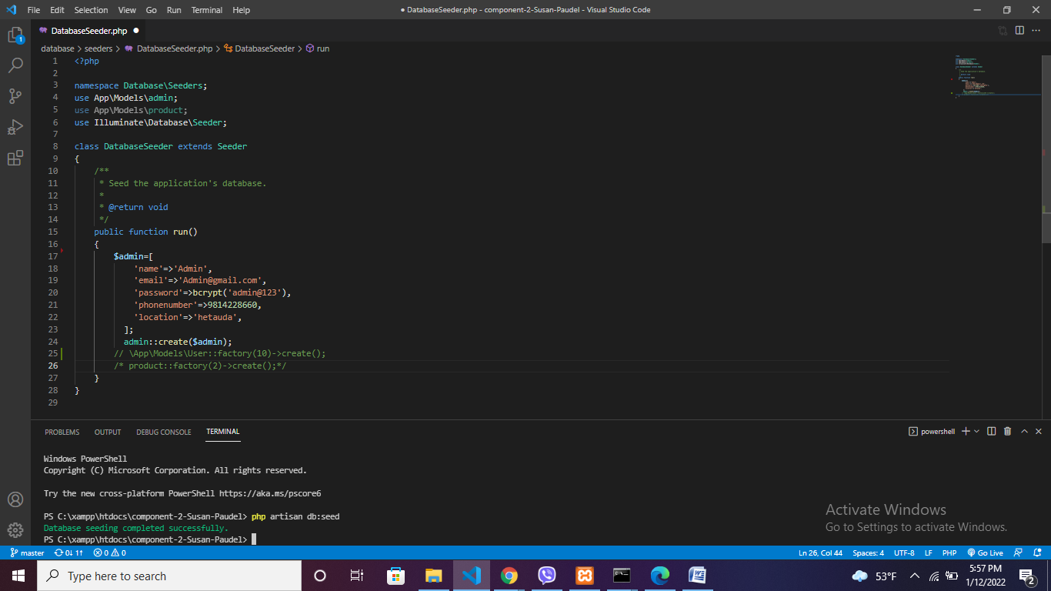

# Creating dummy data using faker

Factory used faker to make dummy data and seeder to call the factory function and model in seeder file.

